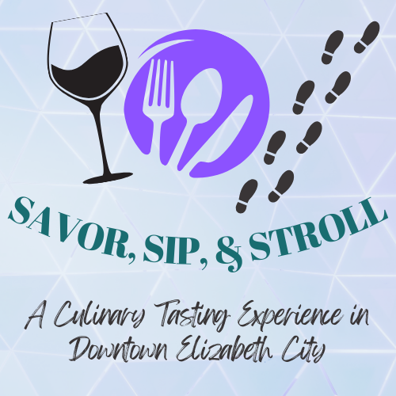

***A Culinary Tasting Event in Downtown Elizabeth City***

**Thursday, March 6th, 2025**

**“Savor, Sip, and Stroll” is a culinary “crawl” through downtown Elizabeth City. Ticketholders will visit participating restaurants, watering holes, and shops for a small sampling of food and/or beverages.**

**Tickets are $50 and will be limited to a maximum of 250 attendees.**

**Proceeds from the event will benefit Albemarle Hopeline, which serves victims and survivors of domestic and sexual violence in our community.**

**As a Participating “Stroll Stop,” You Will Receive:**

* Up to 250 potential new customers to taste your venue’s fare- use this opportunity to spotlight your business and expand your brand recognition!
* Logo and link to your venue on the event website for attendees to learn more about your fare (they may just get so hungry they come visit you sooner!)
* Exposure through social media marketing.
* Disposables provided by the event (must pre-order by February 10th).
* Designated volunteers at your location during the event to guide traffic and help hand out samples.
* The opportunity to provide follow-up offers to attendees such as coupons or special discounts to entice them to return!
* Alignment with charitable works in the community – you will also receive a tax receipt for your contributions of food and labor.

You can still be open for regular business during the event, and entice attendees to stay for a drink or dessert!

**Stroll Stop Participation**

**What We Ask of You:**

* Provide a sample of food and/or drink for up to 250 attendees (headcount will be provided by the event 10 days prior but will *not* exceed 250 people).

**Get creative and use this as an opportunity to really showcase your business! Do you want people to know that you have a great dessert menu or that you also cook a delicious brunch? You can also choose to partner with other local providers to feature their ingredients!**

* Provide a separate table / space for guests to sample and linger.
* Permit sponsor signage at your location during the event.
* Help to promote the event through your own social media and signage at your location.
* Pre-order your disposables through Hopeline by February 10th .
* E-mail your logo to [ccottrell@albemarlehopeline.org](mailto:ccottrell@albemarlehopeline.org) for use in event marketing.

**Stroll Stop Commitment Form**

Venue Name: _________________________________________________

Contact Name:_________________________________________________

Best Phone #: __________________________________________________

E-mail: ______________________________________________________

Point of Contact During the Event : ____________________________________________________________

Website: ______________________________________________________

Printed Name of Owner/Manager: ____________________________________

Signature: _____________________________________________________

Date: _____________________

***Thank you for your support!***